Hospital Management System

Revised Project Plan

# Introduction

Hospital Management System is a special interface designed to make the work of interaction between patients and doctors easier. The idea of creating this system was generated when we were discussing on what systems are lacking behind in terms of the 21st century. The main objective while searching for the potential system to work on was by being solution oriented and by thinking out of the box. We realized that hospitals have not transitioned to being online as most other system have with today’s technology. That was our initial thought process while coming up with this solution, and now whilst revising the plan our thought process is further backed up by the pandemic situation world is facing. With a proper online communication mechanism from patients to doctors would be a massive boon to support the recovering cause from COVID-19. Our Hospital Management system will have a website where patients and doctors can log in. Patients can make their profile and update it, they can give access to specific doctors and ask for suggestion and queries. This system will enable people/patients to be helped from doctors all over the globe. Yes, we do realize that in most cases, patients need to be physically tested, but this system allows day-to-day communication, access to more networks of doctors from different fields and so on. We have revised the vision we wanted to achieve, the plan is to revise the Master plan we have and the risk list in the system we are emerging into. These are very crucial in denominating potential contingencies.

# Project organization

The task has been divided equally and the date of the system to be released has also been fixed. Working in a team is very important whist having proper communication and regular update on the work to be done. After working on this project for a short while we have realized to work on everyone’s strength and so keeping that in mind distributed the task accordingly.

Our outstanding team consists of

* Kushal Regmi
* H.K. Theekshana Ravinath
* Manusha Anjaana Liyanage
* Prabashi Mithma Gunawardana

Following are the divided task and role for each team memebers -

Theekshana

* Working on a Revised Risk List
* Working on a Revised Master Plan
* Working on the Testing Mechanism. He is doing User Accepting Testing, Unit Testing and Integration Testing.
* Excels at coding and testing.

Manusha

* Working on a Revised Project Vision
* Working on a Revised Requirement Model
* Working on Final Documentation.
* Excels in organizing and documenting.

Prabashi

* Working on Final Architecture
* Working on Executable Architecture
* Handling GitHub
* Excels in coding

Kushal

* Working on the Revised Project Plan
* Working on the Elaboration Phase Assessment
* Handling Asana
* Excels in communication and team management

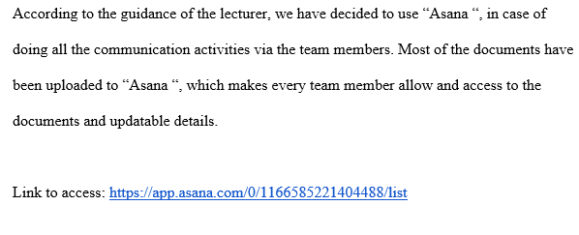

# Project practices and measurements

As outlined on the previous project plan, technical practices has been used in this project. We are very lean on completing the project staying loyal to the Agile unified project practices. From day first in this project all the steps have been followed in iteration. All the tasks are completed in multiple iteration of planning, discussing and finally implementing. Meeting Minutes records all the activity discussed and iteration plan documents the finalized results.

The rest of the practices on the project have fairly been similar as it was discussed beforehand.

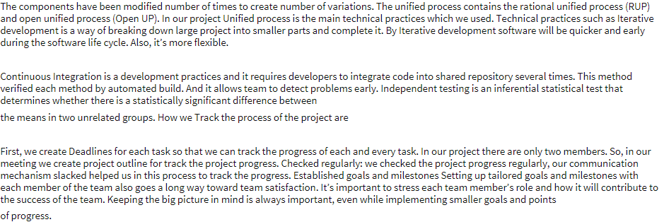

# Deployment

The first step in deploying the project is to create a checklist on things to be brought up in spotlight. Pipelining the task that is required to be done is critical to successfully distribute and implement in the architecture. The use cases that are used on the architecture are carefully determined delegating all the redundancies. He also have adopted Continues Delivery (CD)

We have servers that support the requirements of our system. Database Server Holds all the information of Patients and only gives access to those doctors who are helping that particular person. Therefore, Security layer is implemented in this server to only authorize desired people to give access to information. The Patient will be using website that connects to the Application Layer of the project. This Application layer will be different from patient and doctors, only the login page will be same where all users have to login independently. Patients can communicate with their doctors by sending texts and doctors can recommend patients to other doctor if they require assistance from doctors from another field. Down the line, the strategy is to use this system to connect hospitals all around the globe to increase the database. This will hopefully bring all the best minds in medical field together to make research and other aspects easier. If a system like this was thriving before the outbreak, maybe lots of precaution could have been implemented earlier all around the world to stop the spread of the virus.

The deployment strategy finally is to having regular update session to warn members on the changes to be made and alert them with updates in real time.

# Project milestones and objectives

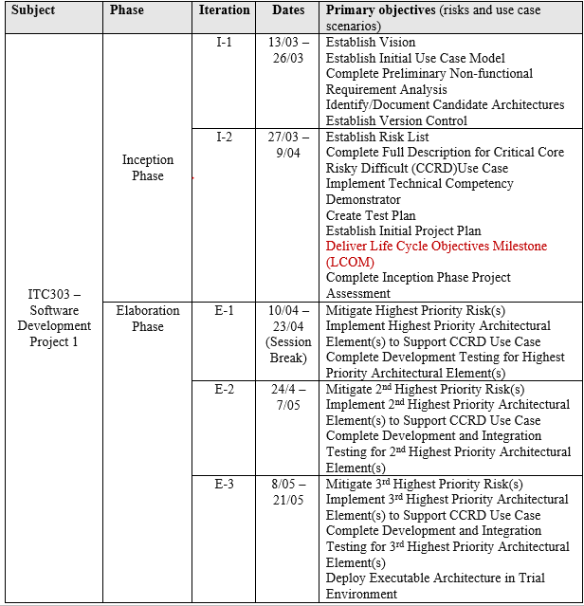

|  |
| --- |
| Mid-year Semester Break |

